Create a directory called ""my_folder"", navigate into it, and create a file named ""my_file.txt"" with some text. Then, create another file named ""another_file.txt"" with some text. Concatenate the content of ""another_file.txt"" to ""my_file.txt"" and display the updated content. Finally, list all files and directories in the current directory.

1. **Create a directory :** mkdir my_folder  
   **Create a file name:** touch my_file.txt

touch another_file.txt

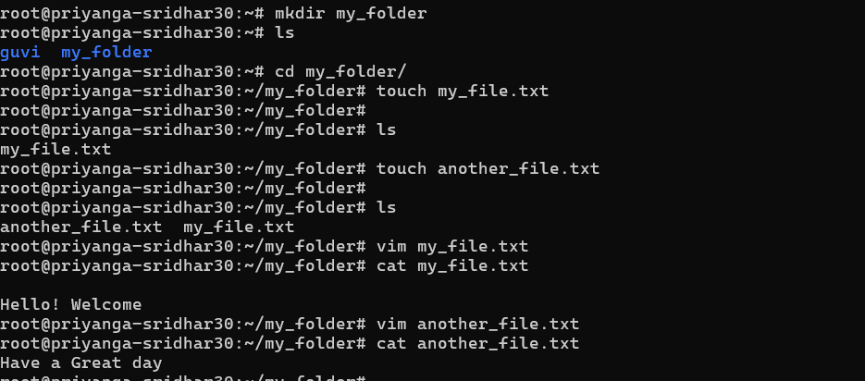

2.Create file named **"another_file.txt" and "my_file.txt"** with some text.   
3. Concatenate the content of ""another_file.txt"" to ""my_file.txt"" and display the updated content.

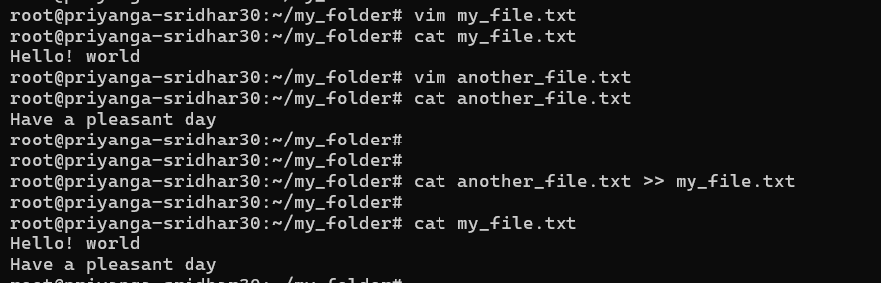

4. List all files and directories in the current directory

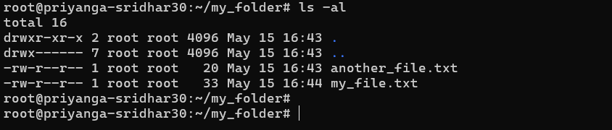

Create 20 files with .txt extensions and rename the first 5 files to .yml extension and Print the latest created top 5 files among the total no of files

1. Create 20 files with .txt 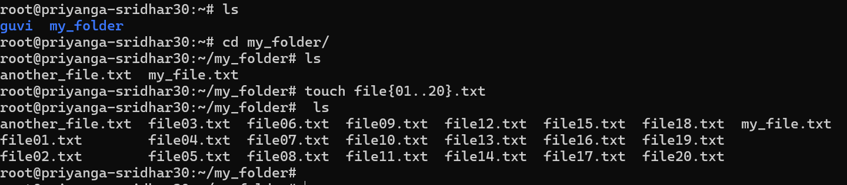
2. rename the first 5 files to .yml extension

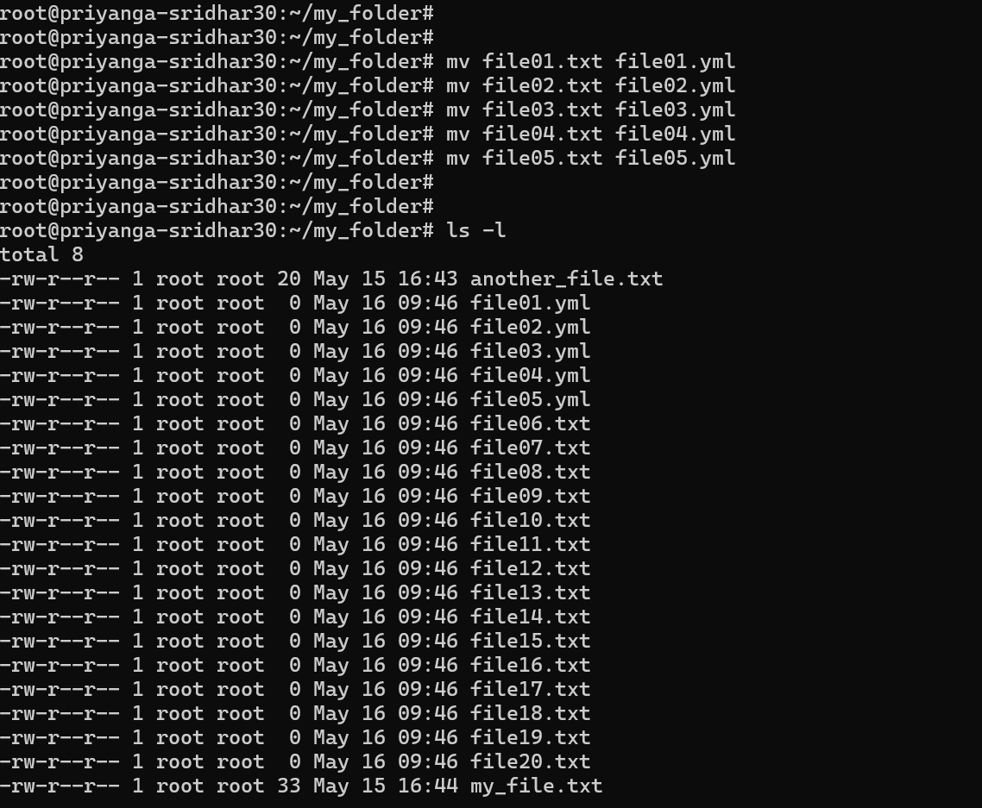

3.Print the latest created top 5 files among the total no of files

